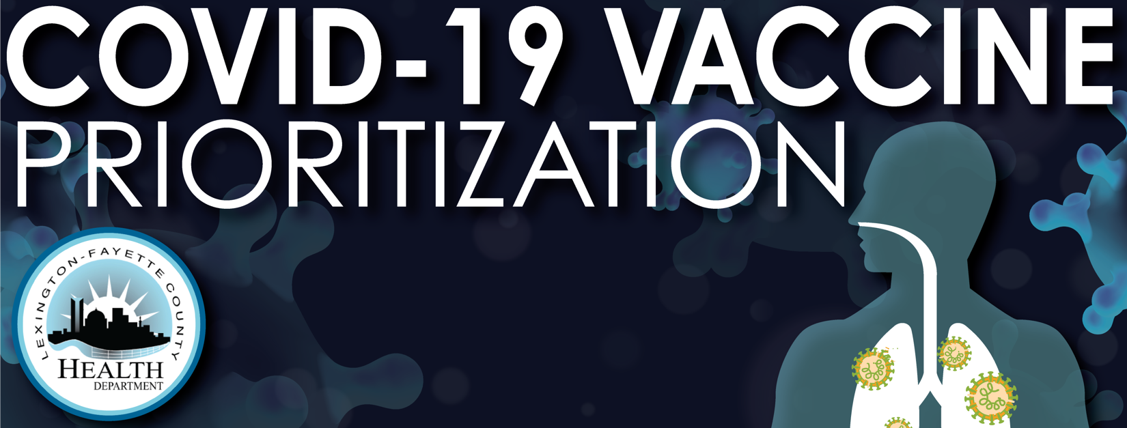

The Lexington-Fayette County Health Department is currently in Phase 1A and will provide an appointment-only COVID-19 mass vaccination clinic for non-hospital healthcare workers. Each recipient must register in advance.

We are asking that this clinic be limited to:

* Providers/staff from Lexington practices who have not registered to receive doses of the vaccine; AND
* Providers/staff who are not expected to receive vaccine through their employer or as hospital staff; AND
* Providers/staff who have direct patient interface: AND
* Providers/staff who are at higher risk for complication from COVID-19, including those who are 50 and above and those with underlying health issues, as lung, heart or kidney diseases.

The vaccine will not be administered to those who have already received a COVID-19 vaccine, those who have been vaccinated with any other vaccine within the 14 days prior to vaccination, and those who are not feeling well or have not yet recovered from a current COVID-19 infection.

01/05/2021