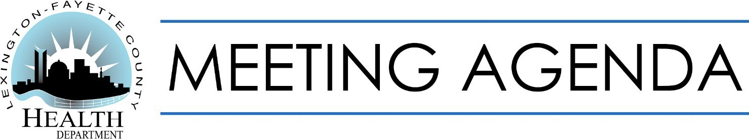

|  |  |
| --- | --- |
| **Finance Committee** | July 12, 2021  4:30 p.m. |
| **OBJECTIVE:** To discuss matters of interest and concern to the Finance Committee. | |
| **TOPICS** | |
| June 14, 2021 Minutes | |
| May Financial Statements | |
| IRB Update | |
| Unplanned Closure Policy “Update” | |
| Contract Employees under H.B. 8 - Update | |
| 2022 Tax Rate | |
|  | |
|  | |
|  | |
|  | |
|  | |
|  | |
| *Upcoming Events*:   * July 12 (5:45 p.m.): Board of Health Meeting | |

Helping Lexington be well.