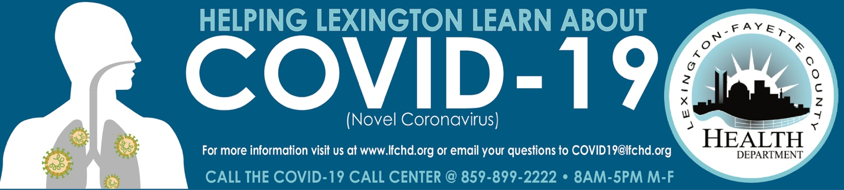

COVID-19 Close Contact and Self Quarantine Guide

WHO IS A COVID-19 CASE?
People who test positive for COVID-19 are “cases” and considered infectious from two days before symptoms started or two days before they are tested for COVID-19 whichever date is earlier, regardless of vaccination status. We are encouraging anyone age 12 or older to receive the COVID-19 vaccine. People who test positive for COVID-19 are considered a case regardless of it they show symptoms of infection, or not (asymptomatic).

WHO IS A CLOSE CONTACT?
A close contact is someone who lives in a home with a person with a confirmed or probable COVID-19 infection, or someone who spent 15 minutes or more within 6 feet of an infectious person with or without mask.

If you are a close contact who is fully vaccinated (14 days or more after 2nd dose of two dose series or 1st dose of a one dose series):
- If you are fully vaccinated more than 14 days and do not have symptoms, you do NOT need to quarantine, but need to monitor for symptoms.
- If you are fully vaccinated more than 14 days and develop symptoms, you need to quarantine and reach out to your health care provider about testing for COVID-19.
If you are a close contact who is NOT fully vaccinated the following may apply to you:
- If you are not fully vaccinated (only one dose of two dose series or not at all) you will need to quarantine. The quarantine period begins from the last date of exposure to an infectious person. There are three different ways you can quarantine if you have NO symptoms:
- Quarantine for 14 days, especially if you are going to be around people that are high-risk for the virus: elderly, people who are immunocompromised, people with co-morbidity (recommended).
- Quarantine for 10 days if you have NO symptoms.
- Quarantine for 7 days if you have a negative COVID-19 test on or after day 5 and have NO symptoms.
- If you are not vaccinated and develop symptoms, you need to quarantine and reach out to your health care provider about testing for COVID-19.

7/6/21

