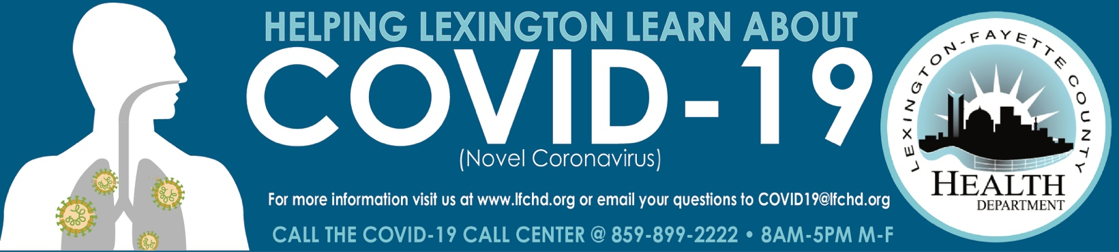

Guidance for Continued Use of Face Coverings
Currently authorized vaccines in the United States are highly effective at protecting vaccinated people against symptomatic and severe COVID-19. A growing body of evidence suggests that fully vaccinated people are less likely to have asymptomatic infection or transmit SARS-CoV-2 to others. Risk of SARSCoV-2 infection is minimal for fully vaccinated people. The risk of SARS-CoV-2 transmission from fully vaccinated people to unvaccinated people is also reduced. Therefore CDC guidance has been updated indicating that fully vaccinated people no longer need to wear a mask or physically distance in any setting, except where required by federal, state, local, tribal, or territorial laws, rules, and regulations, including local business and workplace guidance.

People are considered fully vaccinated for COVID-19 ≥2 weeks after they have received the second dose in a 2-dose series (Pfizer-BioNTech or Moderna), or ≥2 weeks after they have received a single-dose vaccine (Johnson & Johnson [J&J]/Janssen). There is currently no post-vaccination time limit on fully vaccinated status. Unvaccinated people refers to individuals of all ages, including children, that have not completed a vaccination series or received a single-dose vaccine, or are within <2 weeks of completion of a vaccination series.
Settings where face coverings are mandated:
There are some high-risk settings where face coverings continue to be required regardless of vaccination status. Per the Governor’s Executive Order universal compliance with face coverings is required for both fully vaccinated and unvaccinated persons aged 5 years or older who are not otherwise exempt in:
• Public transit and transportation hubs
• Healthcare settings
• Long term care settings
• Correctional facilities
• Homeless shelters
Considerations for Continued Use of Face Coverings in Other Settings
Persons who are not fully immunized should continue to follow CDC prevention measures, including wearing a face covering in public indoor and outdoor settings, maintaining physical distancing of 6 feet or more, and avoiding crowded and poorly ventilated spaces. Determining vaccination status among patrons or visitors in public or retail settings is frequently not feasible. As such, Lexington-Fayette County Health Departments recommends use of face coverings for vaccinated and unvaccinated individuals in indoor settings where risk of SARS-CoV-2 is increased, particularly where it is likely that unvaccinated persons may be present and physical distancing is not possible. This may include settings such as:
• Non-healthcare congregate living
• Indoor gathering places
• Child care facilities
• Schools with young children
• Indoor retail establishments
• Indoor music, sports, and entertainment venues

7/6/2021

